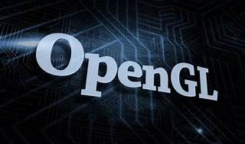

Explore

[**OpenGL** is a cross-language, cross-platform application programming interface (API) used for rendering **2D and 3D vector graphics** by interacting with a graphics processing unit (GPU) to achieve hardware-accelerated rendering1](https://en.wikipedia.org/wiki/OpenGL). Here are **five free reference links** where you can learn more about OpenGL:

1. [**OpenGL Official Website**](https://www.opengl.org/): The industry standard for high-performance graphics, providing essential resources, tools, and libraries[2](https://www.opengl.org/).
2. [**GLFW**](https://www.glfw.org/): A library that gives you a window and OpenGL context with just two function calls. [It supports OpenGL, OpenGL ES, Vulkan, and related options, flags, and extensions](https://en.wikipedia.org/wiki/OpenGL)[3](https://www.glfw.org/).
3. [**OpenGL on Wikipedia**](https://en.wikipedia.org/wiki/OpenGL): A comprehensive overview of OpenGL, including its history, features, and applications[1](https://en.wikipedia.org/wiki/OpenGL).
4. **LearnOpenGL**: A fantastic resource with tutorials, examples, and exercises to help you learn OpenGL step by step.
5. **OpenGL Tutorial**: Offers practical tutorials and explanations for beginners, covering topics like shaders, buffers, and rendering techniques.

Happy learning! 🌟🎨